Mortgage originations
Held mortgage originations at zero for 24 months.
Then for the next 36 months, fit curve according to previous historical ramp-up rate.

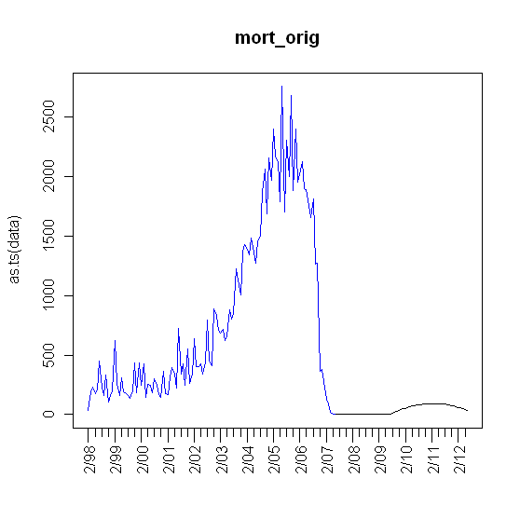

Foreclosures
Assumed recovery in 24 months, as in mortgage originations.
Obtained cumulative foreclosure estimates for 2008-2009 from the “Center of Responsible Lending.”

Idaho Original data
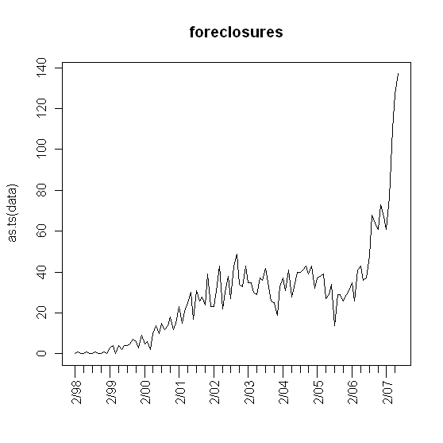

Cumulative foreclosure estimates plot

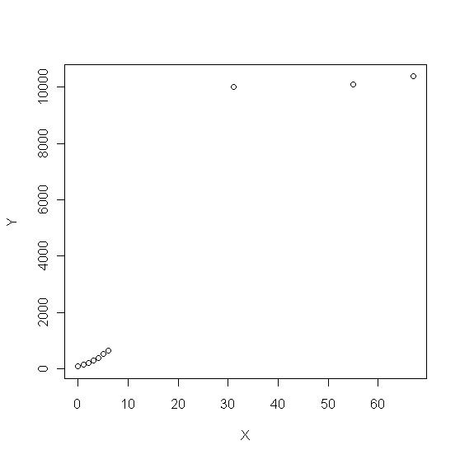

Idaho Foreclosures Forecast

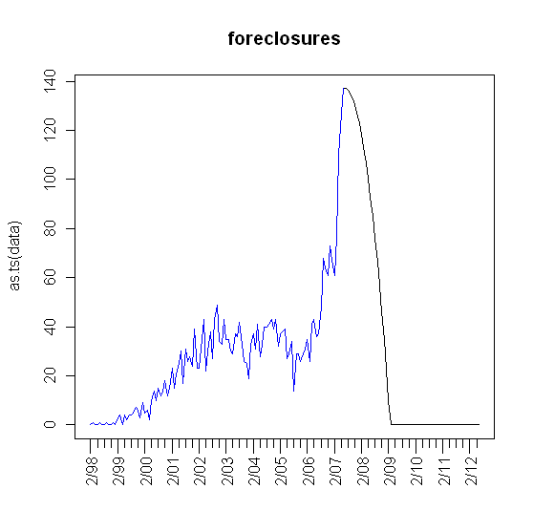

Unemployment Rate
Assumed periodic. Fit 4th order polynomial using the most recent peak and trough.

Idaho Original data
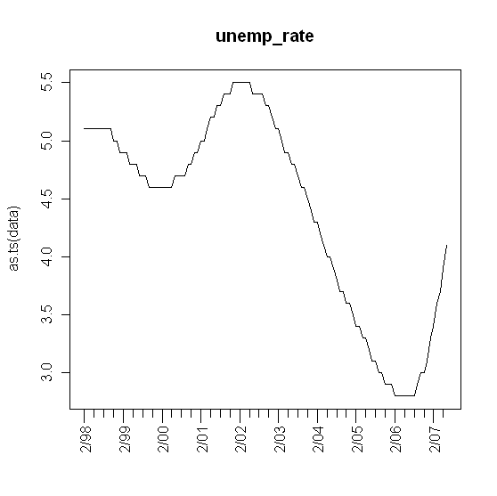
Initialization
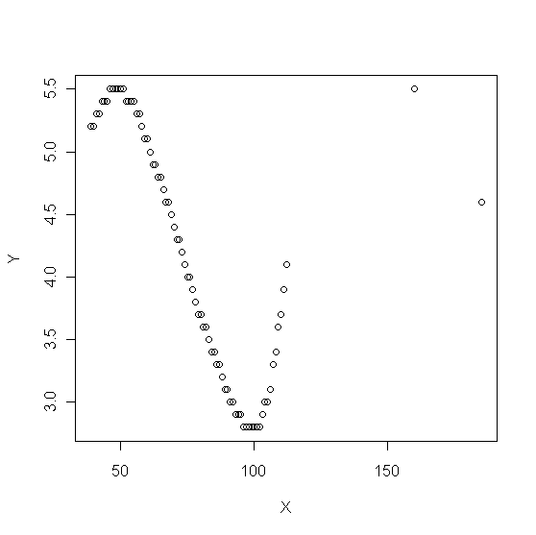

Idaho Unemployment Rate Forecast

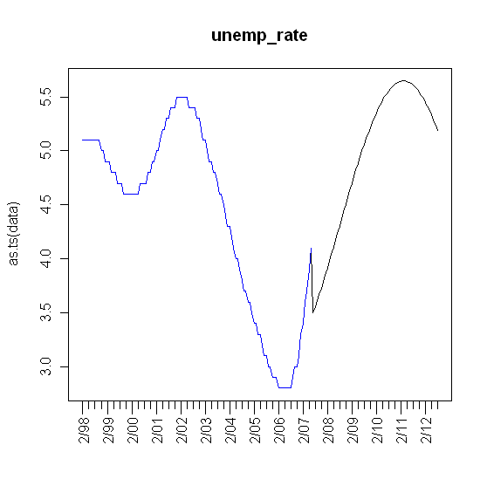

Median income
Assumed stationary about the last 2-year moving mean.

Building permits

